INTERMEDIAL PERFORMANCE AESTHETICS IN PATRICIA FAGUNDES’ A MIDSUMMER NIGHT’S DREAM

ESTÉTICA DE ENCENAÇÃO INTERMIDIÁTICA EM SONHO DE UMA NOITE DE VERÃO DE PATRICIA FAGUNDES

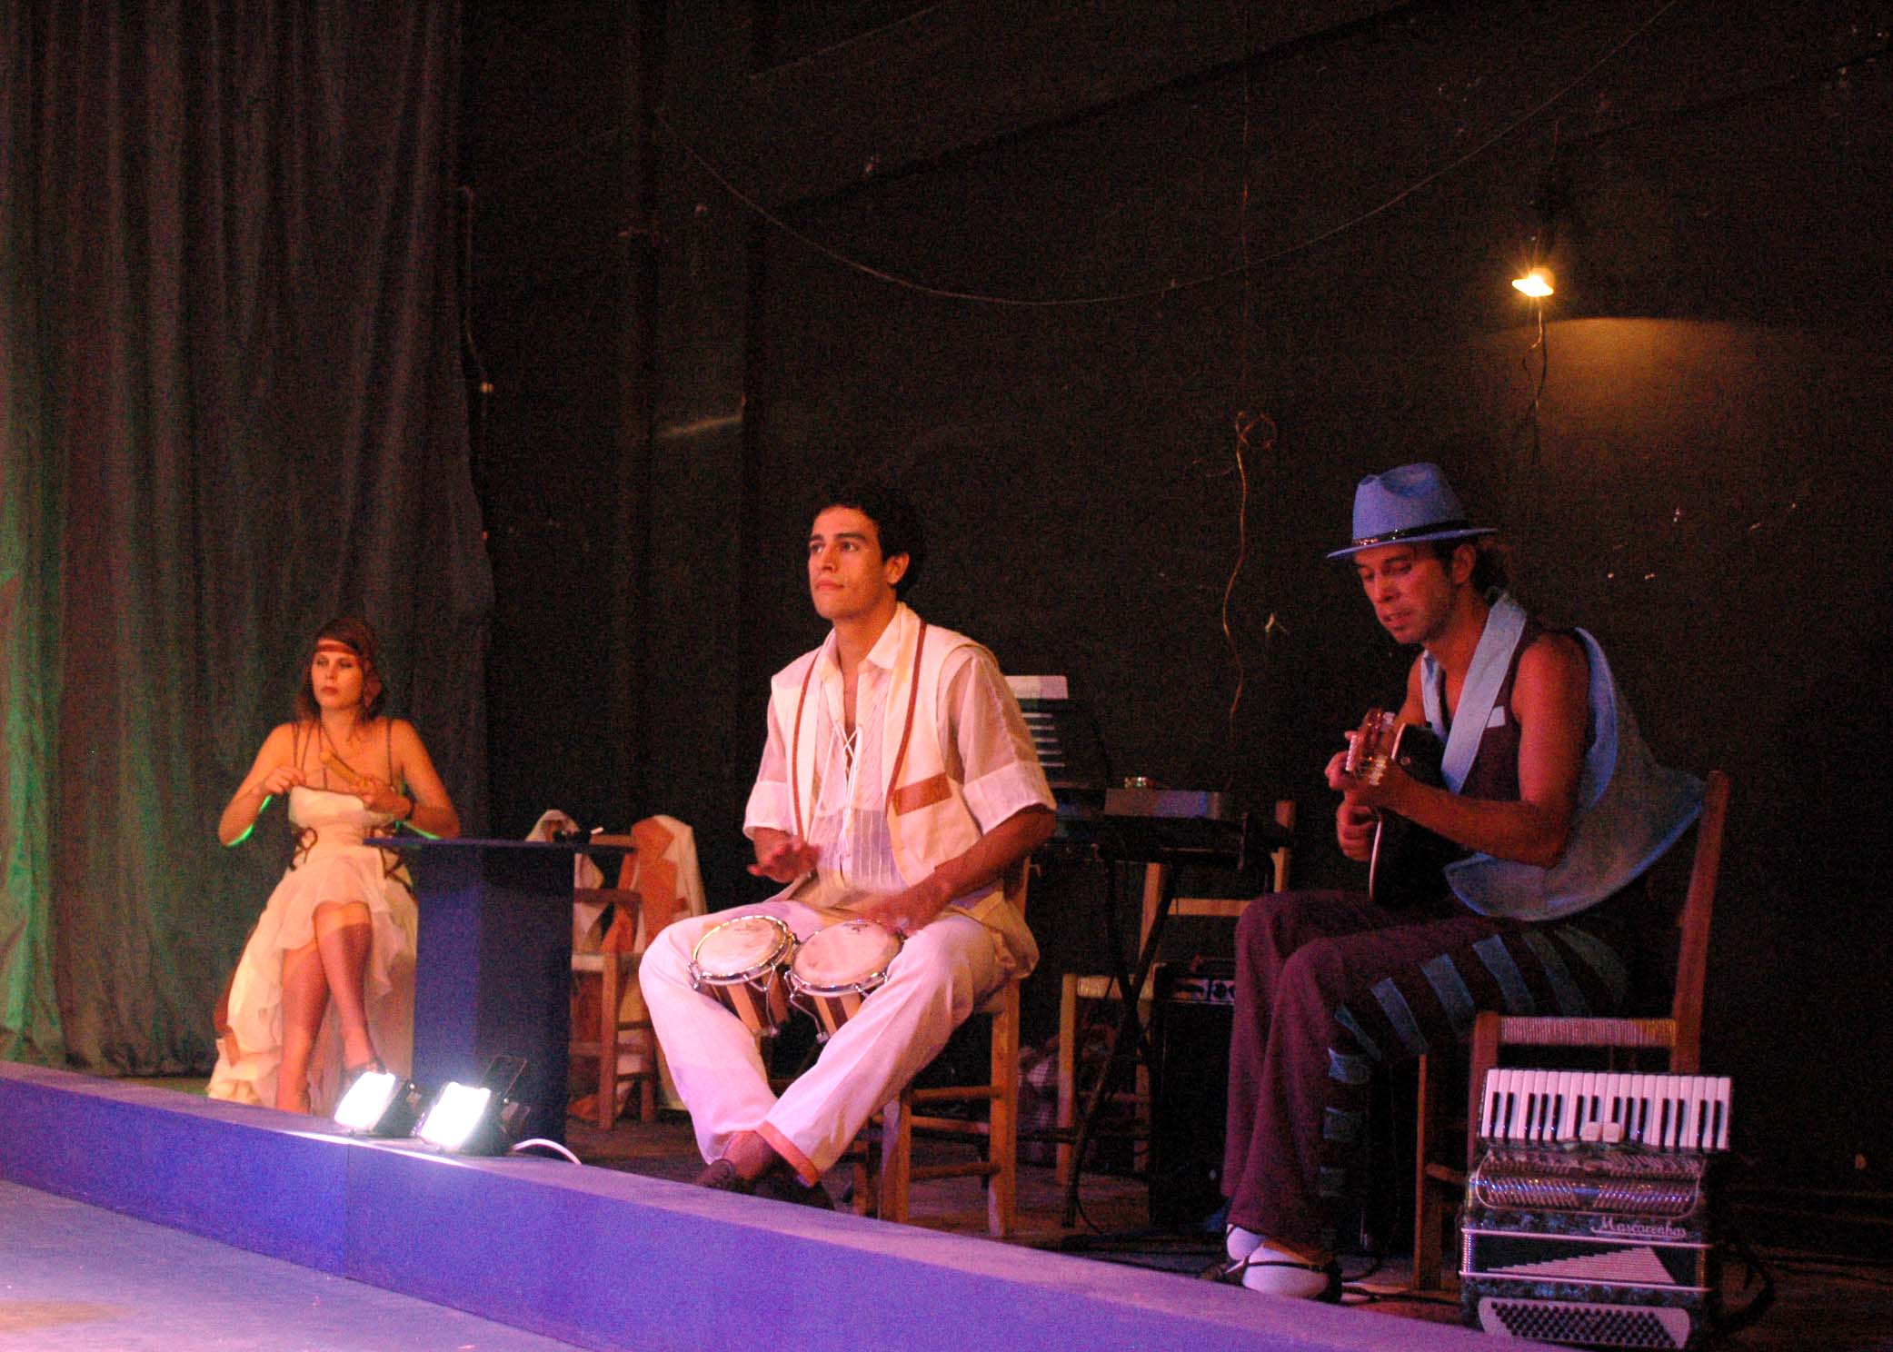
Fig. 1 – Actors doubling as musicians, playing live music when not acting.

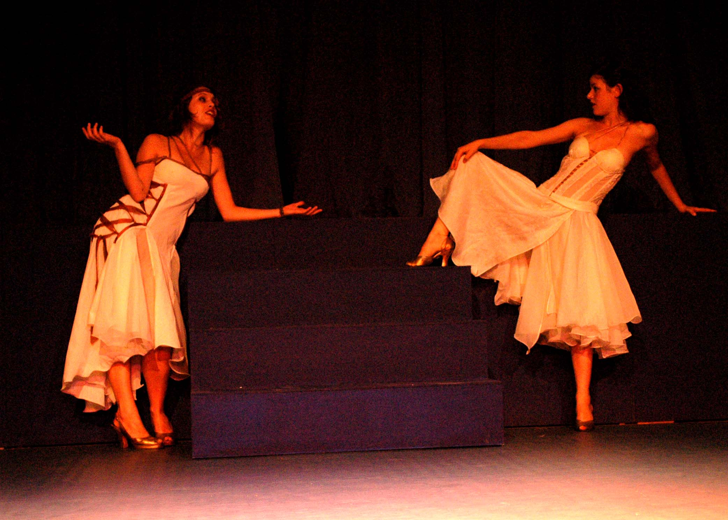

Fig. 2 – The heroines’ musical duet in cabaret ambience.

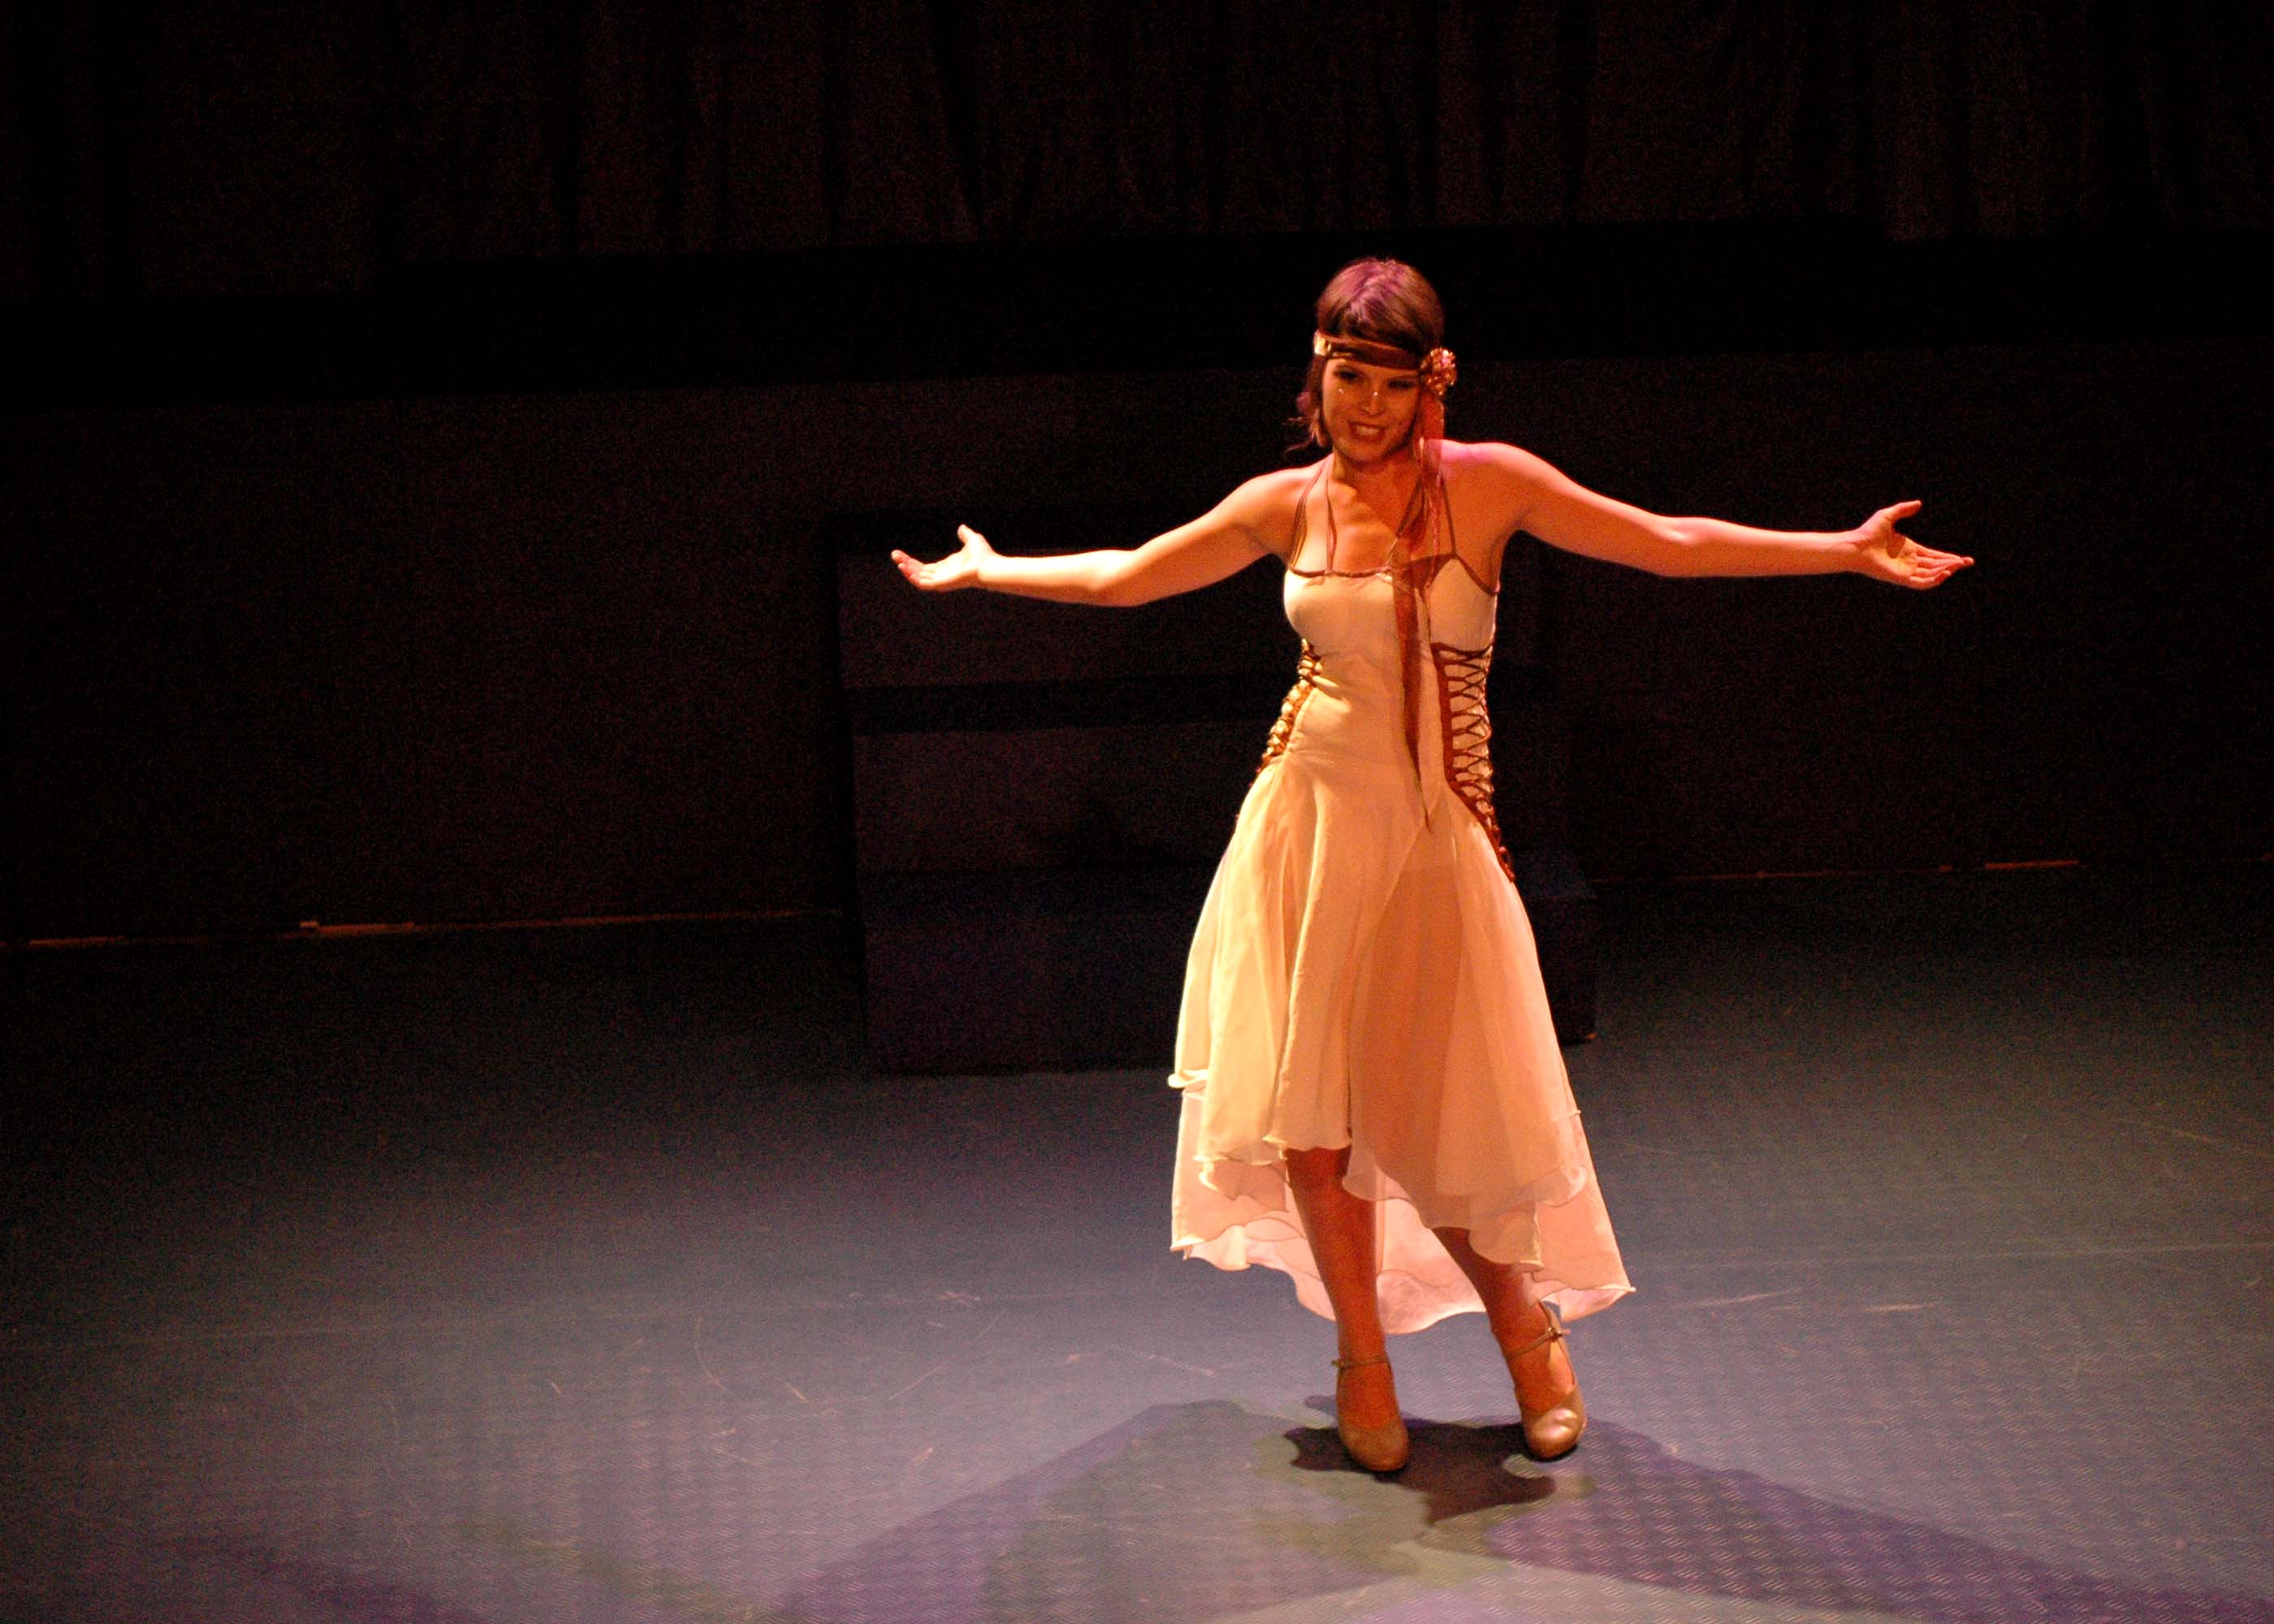
Fig. 3 – Helena’s soliloquy transmuted into a musical number.

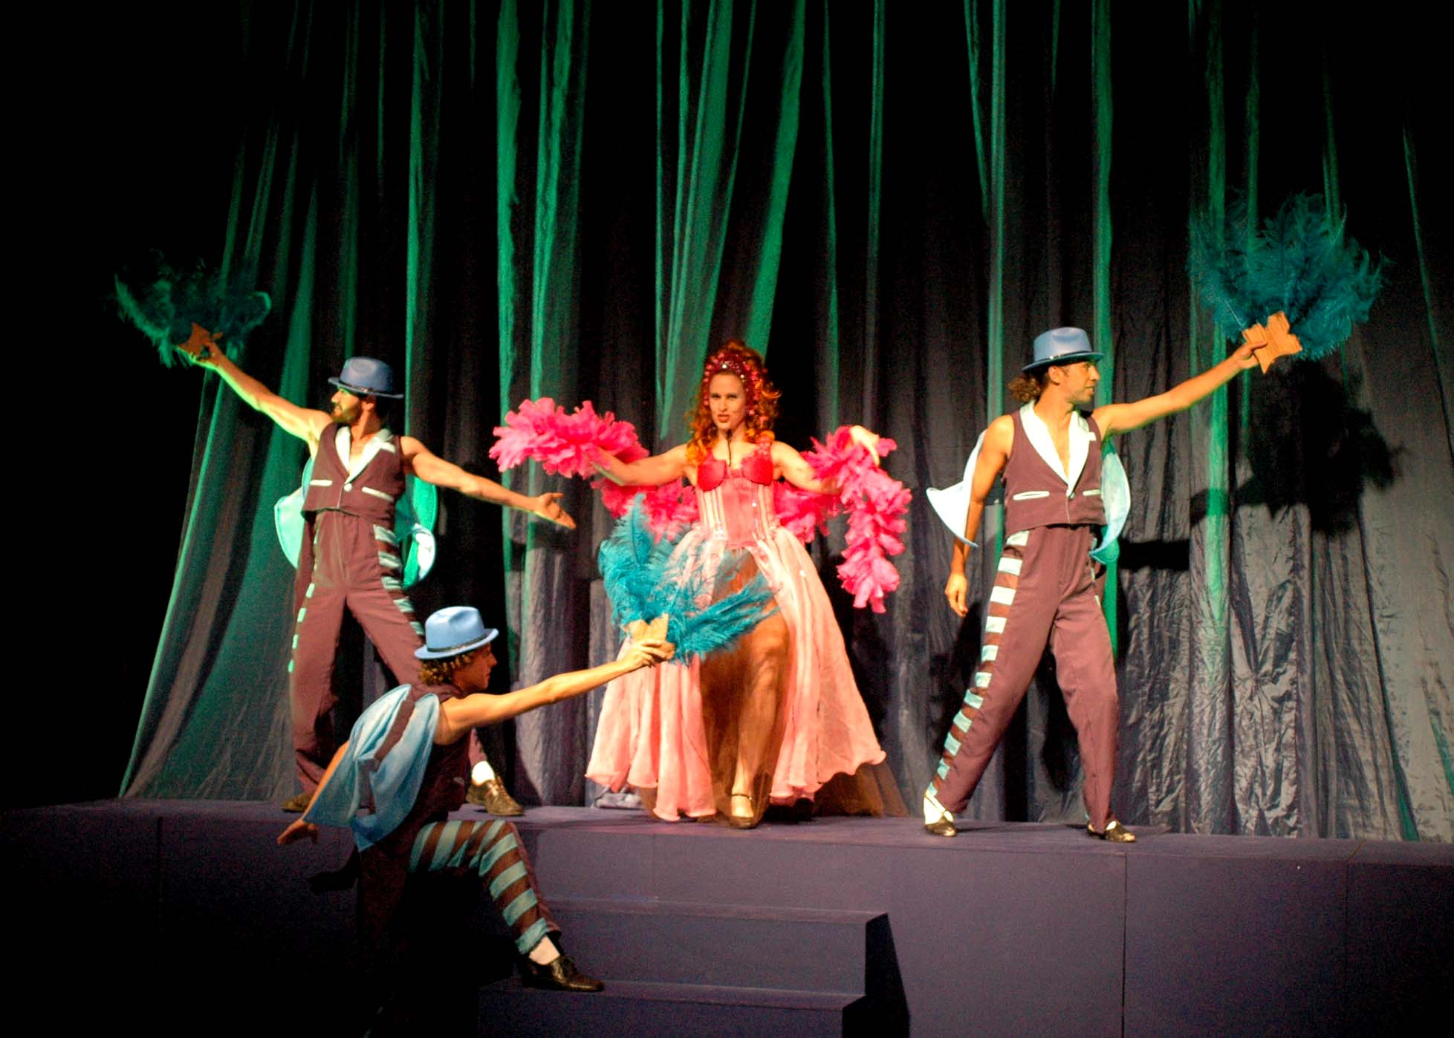
Fig. 4 – Titania’s spectacular entrance with her adult male fairies.

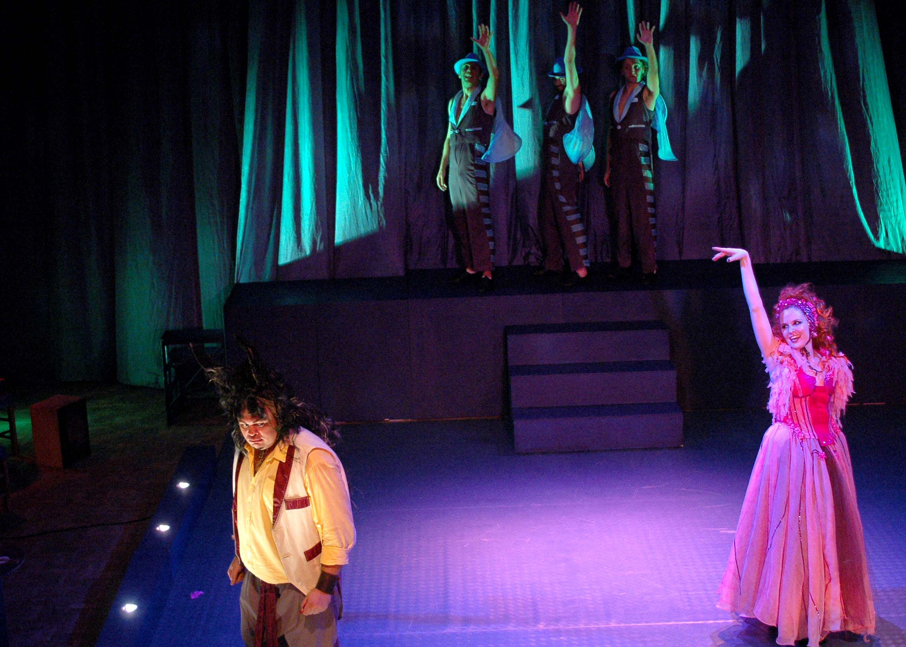
Fig. 5 – Bottom sings a popular Brazilian song.

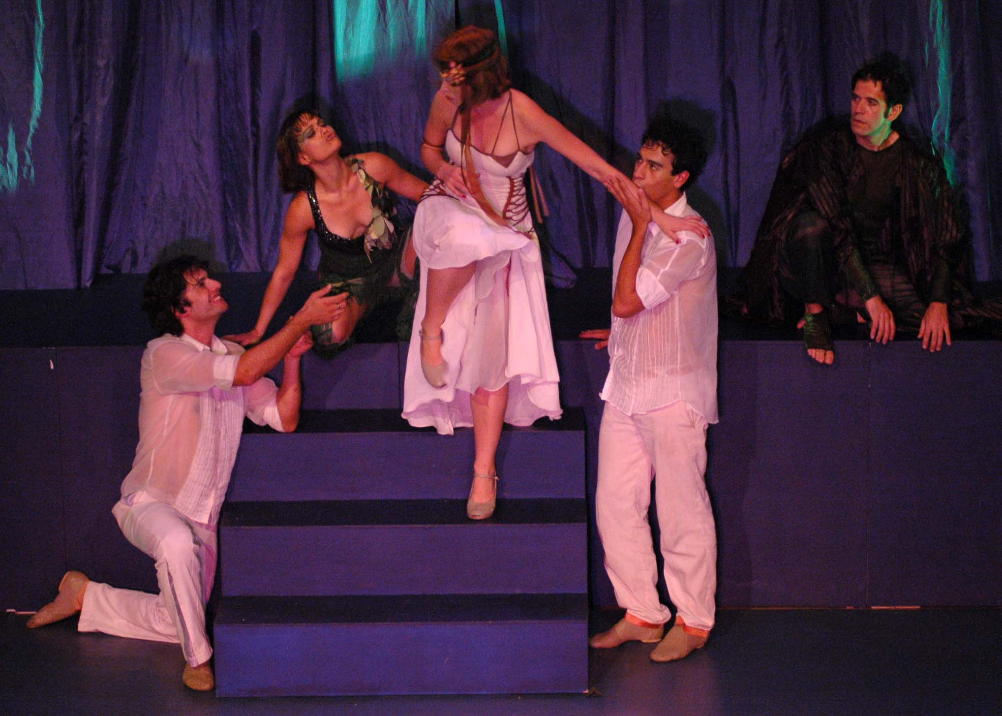
Fig. 6 – Choreographic triangular design: Helena, Demetrius and Lysander.

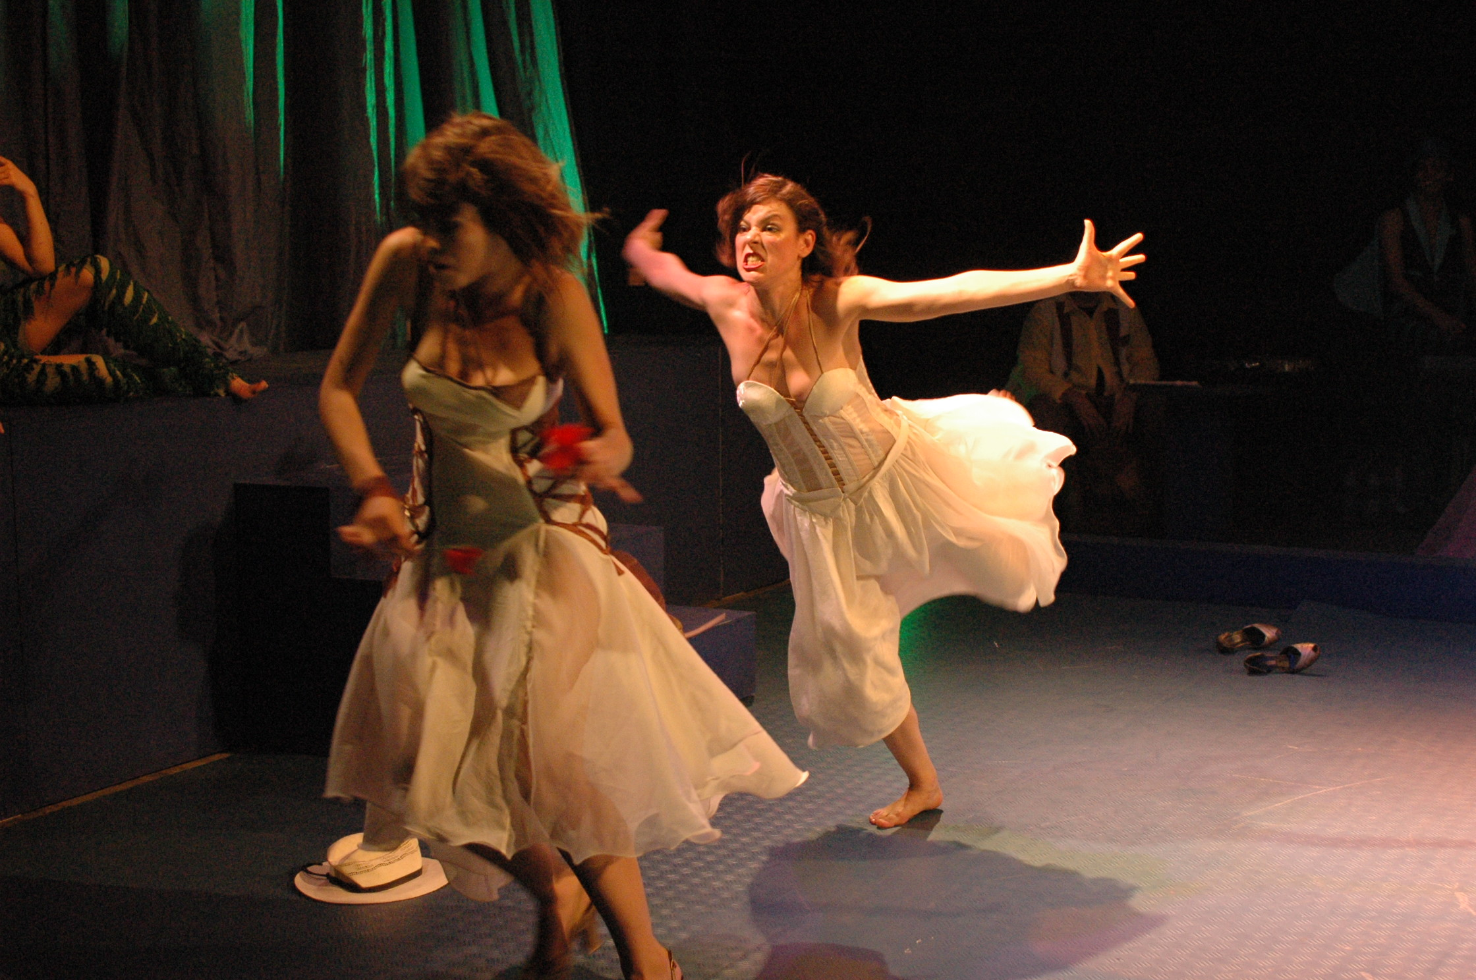
Fig. 7 – Verbal duel designed into choreographed physical action.

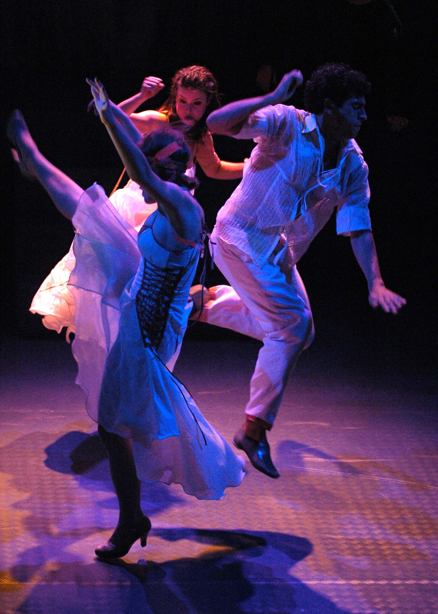
Fig. 8 – Slow motion: theatricalization of cinematic devices.

