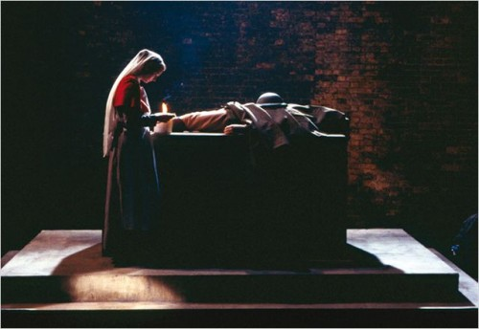
Figura 1: cena inicial de War Requiem, Derek Jarman (1988). São Paulo (SP): Magnus Opus, 2008.

Figura 2: cena inicial de War Requiem, Derek Jarman (1988). São Paulo (SP): Magnus Opus, 2008.

