eISSN 2317-6377

Title of the article in the main language
Title of the article in English (if the main language is Portuguese or Spanish)
Title of the article in Portuguese (if the main language is English)

First author's Name ORCID
University, Department, city, state, country
first author's e-mail

Second author's Name ORCID
University, Department, city, state, country

SCIENTIFIC ARTICLE / INTERVIEW / MUSIC SCORE / BOOK REVIEW  Section Editor:  Layout Editor:  License: "CC by 4.0" | Submitted date:  Final approval date:  Publication date:  DOI: https://doi.org/00.00000/0000-0000.0000.0000

ABSTRACT: Abstract of no more than 150 words. The text should use 1,15 spacing, 10-point, Calibri, justified. This Template uses as an example an article in English. If the article is written in Portuguese or Spanish language, please change the order: TITLE, Abstract and Keywords in the main language of the article (Portuguese OR Spanish) and after in English. Text text text text text text text text text text text text text text text text text text text text text text text text text text text text text text text text text text text text text text text text text text text text text text text text text text text text text text text text text text text text text text text text text text text text text text text text text text text text text text text text text text text text text text text text text text text text
KEYWORDS: Keyword 1; keyword 2; keyword 3; keyword 4; keyword 5.

RESUMO: Abstract of no more than 150 words. The text should use 1,15 spacing, 10-point, Calibri, justificed. Text text text text text text text text text text text text text text text text text text text text text text text text text text text text text text text text text text text text text text text text text text text text text text text text text text text text text text text text text text text text text text text text text text text text text text text text text text text text text text text text text text text text text text text text text text text text text text text text text text text text text text text text text text text text text text text text text text text text text text text text text text text text text text text text text text text text text text.
PALAVRAS-CHAVE: Palavra-chave 1; Palavra-chave 2; Palavra-chave 3; Palavra-chave 4; Palavra-chave 5.

Per Musi | Belo Horizonte | v. | Section | exxxxxx | 2023
1. Introduction (Use Calibri, 16-point bold, orange color)
Use Calibri, 12-point for the text. 1.15 multiple spacing (0pt Before, 10pt After) should be used in all instances, after periods, colons, semicolons. Add line space before paragraph without indent. The text should be justified. (Author Year, page). Generic titles of works should be given in italic. Flats, sharps, and naturals can be indicated by the conventional symbols or spelled out (e.g., C-sharp, D-flat, or B-natural). Example of an article reference (Taruskin 1985, 101; Nettl 2017, 45–46; Locke 2015). Example of a book reference (Clarke 2004; Cook and Everist 2001). Example of a book chapter or Book section (Bohlman 2018, 75, 79). Example of a Conference proceedings (Braga and Rocha 2019).
In case of translating a quotation, consider adding in a footnote the original version of that selected excerpt between quotation marks and in italics. Text text text text text text text text text text text text text text text text text text text text text text text text text text text text text text text text text text text text text text text text text text text text text.
For citations, use Calibre, 12-point, 1.15 spacing and indent 3.0. Text text text text text text text text text text text text text text text text text text text text text text text text text text text text text text text text text text text text text text text text text text text text text text text text text text text text text text text text text text text text text text text text text text text text text text text text text text text text text text text text text text text text text text text text text text text text text text.
2. Title of Chapter (Use Calibri 16-point bold)
Author (Year, page) text text text text text text text text text text text text text text text text text text text text text text text text text text text text text text text text text text text text text text text text text text text text text text text text text text text text text text text text text text text text text text text. Text text text text text text text text text text text text text text text text text text text text text text text text text text text text text text text text text text text text text text text text text text text text text text text text text text text text text text text text text text text text text text text. Text text text text text text text text text text text text text text text text text text text text text text text text text text text text text text text text text text text text text text text text text text text text text text text text text text text text text text text text text text text text text text text text text text text text text text text text text text text text text text text text text text text text text text text text text text text text text text text text text text text text text text text text text text text text text text text text text text text text text text text text text text text text text text.
Text text text text text text text text text text text text text text text text text text text text text text text text text text text text text text text text text text text text text text text text text text text text text text text text text text text text text text text text text text text text text text text text text text text text text text text text text text text text.
2.1. Subtitle of the chapter (Use Calibri 14-point)
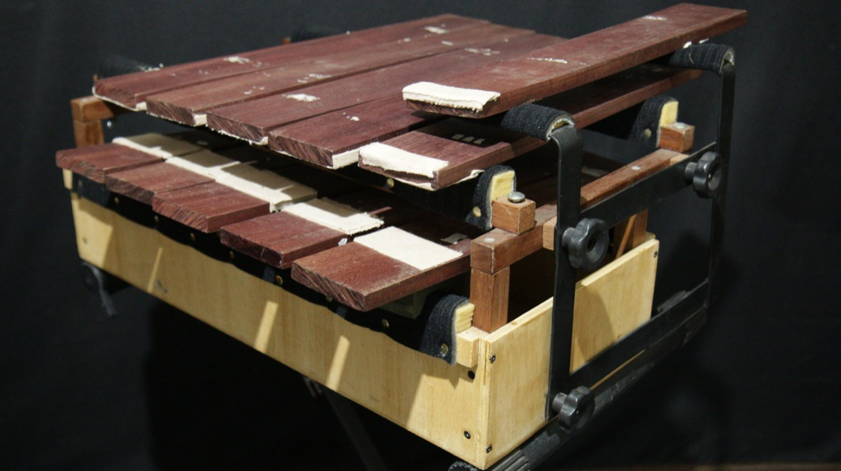

Text text text text text text text text text text text text text text text text text text text text text text text text text text text text text text text text text text text text text text text text text text text text text text text text text text text text text text text text text text text text text text text.
Figure 1 – For the title for the figure, musical example, diagrams or other material, use Calibri, 9-point, bolt, 1 spacing, in the center
Reference: AUTHOR, YEAR; Link, etc.
Text text text text text text text text text text text text text text text text text text text text text text text text text text text text text text text text text text text text text text text text text text text text text text text text text text text text text text text text text text text text text text text.
Tab. 1 – Title for the table. Calibri, 9-point, bolt, 1 spacing, justified

Text text text text text text text text text text text text text text text text text text text text text text text text text text text text text text text text text text text text text text text text text text text text text text text text text text text text text text text text text text text text text text text.
3. References (According to the style of Music Education Research. Automatic bibliographic Software can be used with this formatting)
Bohlman, Philip V. 2018. “Musical Thought in the Global Enlightenments.” In Studies on a Global History of Music: A Balzan Musicology Project, edited by Reinhard Strohm, 1st ed., 61–80. Oxon & New York: Routledge Taylor & Francis Group, LLC.
Braga, Natália, and Edite Rocha. 2019. “Francisco Curt Lange e o Boletín Latino Americano de Música VI : Publicações Da Crítica Musical Brasileira.” Anais Do I Simpósio Internacional Música e Crítica: Lembrança Aos 80 Anos Do Falecimento de Oscar Guanabarino 1: 101–108.
Clarke, Eric. 2004. “Empirical Methods in the Study of Performance.” In Empirical Musicology: Aims, Methods, Prospects, edited by Eric Clarke and Nicolas Cook, 77–102. Oxford: Oxford University Press.
Cook, Nicholas, and Mark Everist. 2001. Rethinking Music. Oxford: Oxford University Press Oxford.
Locke, Ralph P. 2015. “Musicologia e/Como Preocupação Social: Imaginando o Musicólogo Relevante.” Per Musi 32: 8–52. doi:10.1590/permusi2015b3201.
Nettl, Bruno. 2017. “Have You Changed Your Mind?: Reflections on Sixty Years in Ethnomusicology.” Acta Musicologica 89 (1): 45–65.
Taruskin, Richard. 1985. “Chernomor to Kashchei: Harmonic Sorcery; Or, Stravinsky’s ‘Angle.’” Journal of the American Musicological Society 38 (1). University of California Press - American Musicological Society: 72–142. doi:10.2307/831550.

"No caso de traduzir uma citação, considere adicionar em nota de rodapé a versão original desse excerto selecionado entre aspas e em itálico” (Author Year, page).
Foot note: Calibri, 12-point, simple spacing, justified.

