ARTIGO: DOES THE MENTAL LEXICON EXIST?

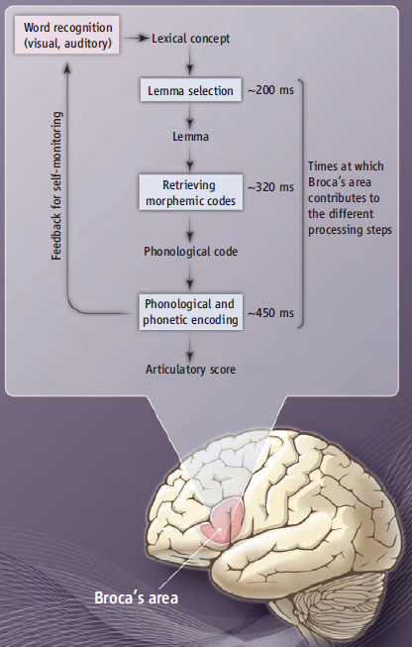

Figure 1. Adapted version of the lexical encoding model for speech production specifying stepwise neuronal processing of language and speech. Source: Hagoort and Levelt (2009, p. 372).

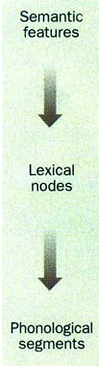
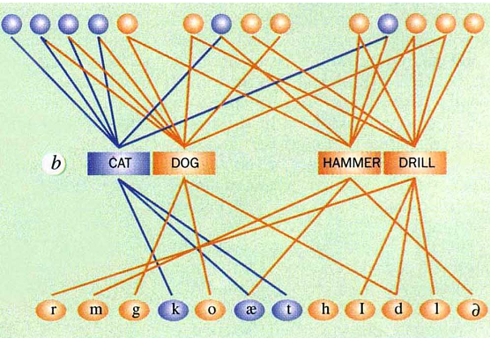

Figure 2. Speech production model. Source: Caramazza (1996, p. 485).

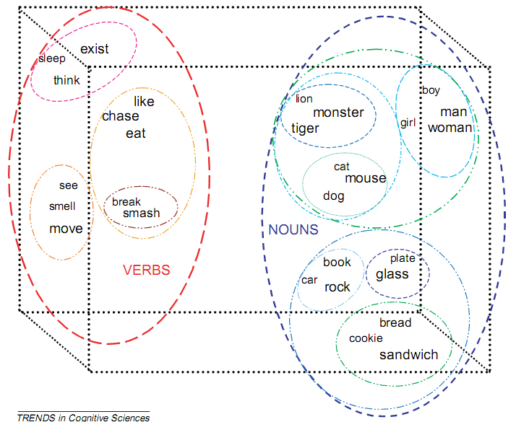

Figure 3. Schematic visualization, in 3D, of the high-dimensional state space
described by the SRN’s hidden-unit layer.
Source: Elman (2004, p. 304).

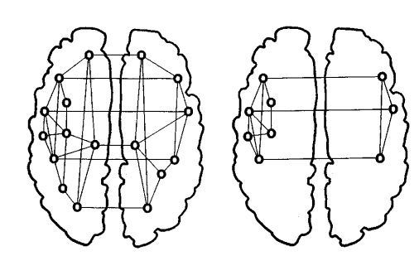
Figure 4. Cell assemblies relevant for cognitive processing may be distributed over both hemispheres and may be lateralized to different degrees. Source: Pullvermüller (1999, p. 261).

